[ Insert official UPAEP logo ]
UPAEP · Decanato de Ingenierías
EVIDENCE — US11-T8
Verify ingestion performance with alert evaluation
SmartGreenAI: Cilantro Crop

1. Task information
Task ID | US11-T8
User Story | US-11 — Receive threshold alerts
Sprint | Sprint 3 (2026-10-12 – 2026-10-30)
Week | Week 3
Responsible | Jorge Velez Delgado
Peer reviewer | Carlos Ramirez Mendoza
Planned / actual hours | 1 h / 1 h
Completed on | October 30, 2026
Status | Done

2. Task description
Send a burst of at least 100 measurements in 1 minute from the simulator and compare the response time of POST /measurements with and without alert evaluation.

3. Completion conditions
✓ Condition 1: Burst test executed with and without evaluation.
How it was verified: The IoT simulator sent the same burst twice to the real API (isolated test database with 24 h of SM-01 history so the anomaly checks work on a realistic window): 120 POST /api/measurements of SM-01 in 56.6 s (one every 0.45 s, more than 100 in one minute), scenario "alerts" — odd cycles leave the range and raise an alert, even cycles resolve it (60 alerts created). Run 1 with the alert evaluation of US11-T4; run 2 with evaluateMeasurement() replaced by a no-op. A 10-request warm-up was discarded.
tools/evidence/ingest_perf.js — lines 95–108
for (const [label, evaluate] of [['with alert evaluation', original], ['without alert evaluation', null]]) {
alertsService.evaluateMeasurement = evaluate || (async () => ({ created: false, resolved: false, alert: null }));
const before = (await db.one('SELECT COUNT(*)::int AS n FROM alerts')).n;
const started = Date.now();
const sim = await simulate(port, COUNT, INTERVAL);
const ended = Date.now();
const summary = summarise(label, sim, started, ended);
summary.alerts_in_db = (await db.one('SELECT COUNT(*)::int AS n FROM alerts')).n - before;
runs.push(summary);
logs[label] = sim.out;
}
alertsService.evaluateMeasurement = original;
server.close();

Simulator log, run with alert evaluation (excerpt) (attached: US11-T8_Verify_Ingestion_Performance_Alert_Evaluation_2.log)
SmartGreenAI simulator · scenario "alerts" · every 0.45 s · speed x1 · API http://127.0.0.1:65519/api
22:47:28 → 1/1 readings stored in 25 ms | soil 55.5 % | 1 new alert(s)
22:47:29 → 1/1 readings stored in 19 ms | soil 68.3 %
22:47:29 → 1/1 readings stored in 21 ms | soil 55.3 % | 1 new alert(s)
22:47:29 → 1/1 readings stored in 16 ms | soil 67.8 %
22:47:30 → 1/1 readings stored in 17 ms | soil 55.5 % | 1 new alert(s)
22:47:30 → 1/1 readings stored in 20 ms | soil 67.8 %
22:47:31 → 1/1 readings stored in 17 ms | soil 55.2 % | 1 new alert(s)
22:47:31 → 1/1 readings stored in 16 ms | soil 67.9 %
22:47:32 → 1/1 readings stored in 17 ms | soil 55.6 % | 1 new alert(s)
22:47:32 → 1/1 readings stored in 15 ms | soil 67.8 %
22:47:33 → 1/1 readings stored in 17 ms | soil 55.6 % | 1 new alert(s)
22:47:33 → 1/1 readings stored in 15 ms | soil 68 %
22:47:34 → 1/1 readings stored in 16 ms | soil 55.2 % | 1 new alert(s)

✓ Condition 2: Average and maximum response times recorded.
How it was verified: Average and maximum recorded: with evaluation 17.2 ms average / 66 ms maximum (p95 22 ms); without evaluation 11.9 ms / 17 ms. The alert evaluation adds 5.3 ms on average.
Response time of POST /api/measurements (round trip measured by the simulator)
Run | Requests | Burst duration | Average | Median | p95 | Max | Alerts created
with alert evaluation | 120 | 56.6 s | 17.2 ms | 16 ms | 22 ms | 66 ms | 60
without alert evaluation | 120 | 55.7 s | 11.9 ms | 12 ms | 14 ms | 17 ms | 0

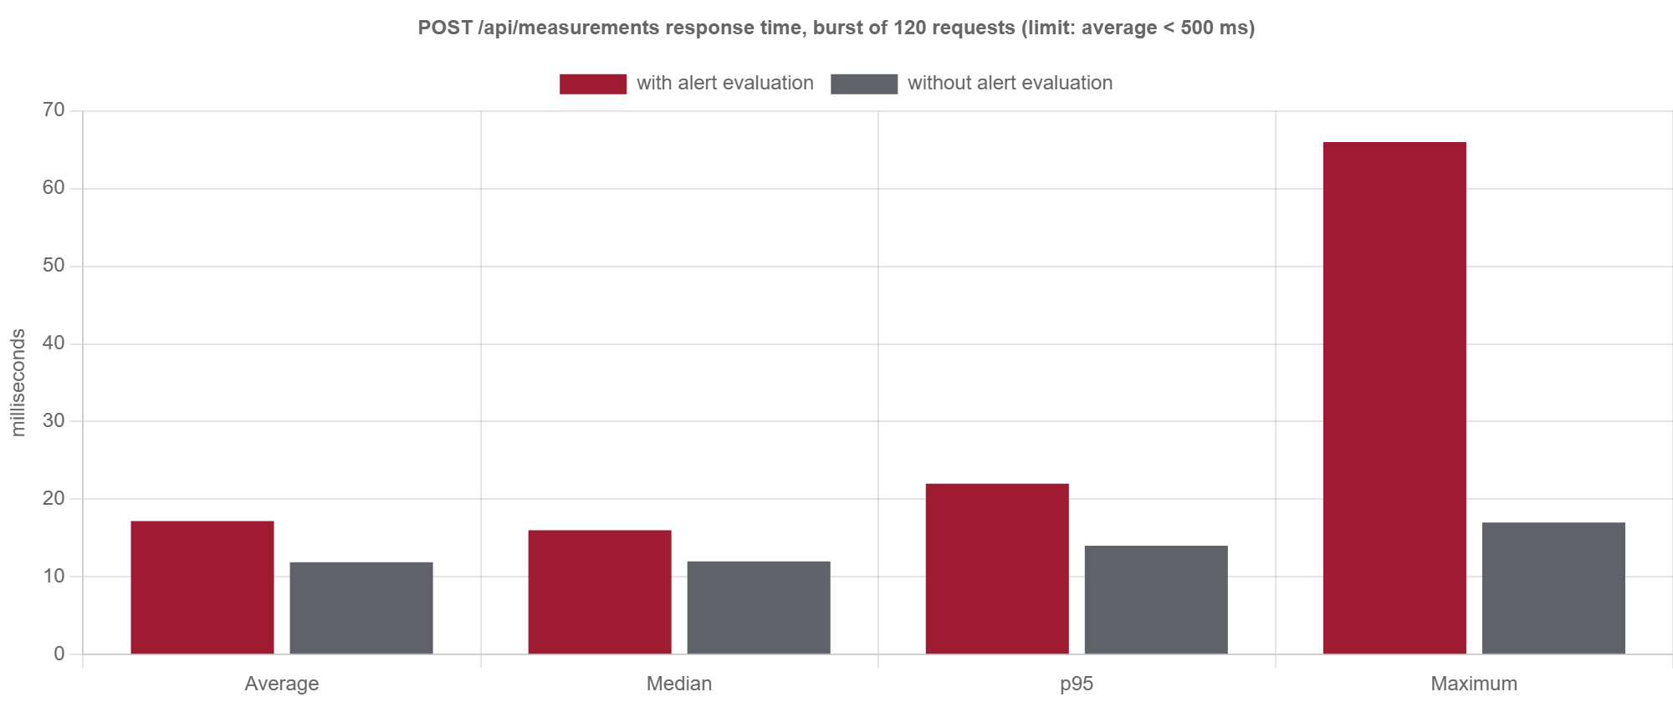
Figure US11-T8-1. Response times with and without alert evaluation (data: attached JSON). (US11-T8_Verify_Ingestion_Performance_Alert_Evaluation_4.png)
✓ Condition 3: Average response time stays below 500 ms or a defect is registered.
How it was verified: The average response time with alert evaluation (17.2 ms) stays below 500 ms, 29 times under the limit; no defect is registered.
✓ Condition 4: Evidence: Response time table and simulator log.
How it was verified: Response time table and simulator logs (US11-T8_Verify_Ingestion_Performance_Alert_Evaluation_1.json, US11-T8_Verify_Ingestion_Performance_Alert_Evaluation_2.log, US11-T8_Verify_Ingestion_Performance_Alert_Evaluation_3.log).
Simulator delivery report, run without alert evaluation (attached: US11-T8_Verify_Ingestion_Performance_Alert_Evaluation_3.log)
=== Delivery report (US06-T5) ===
cycles: 120 · readings generated: 120 · accepted by the API: 120 · rejected: 0
success rate: 100.0 % · average round-trip: 12 ms · max: 17 ms
failed attempts: 0 · readings that went through the buffer: 0 · dropped (buffer full): 0 · still buffered: 0

4. Attached files
- US11-T8_Verify_Ingestion_Performance_Alert_Evaluation_1.json
- US11-T8_Verify_Ingestion_Performance_Alert_Evaluation_2.log
- US11-T8_Verify_Ingestion_Performance_Alert_Evaluation_3.log
- US11-T8_Verify_Ingestion_Performance_Alert_Evaluation_4.png

5. Traceability
Related requirements | FR-12, FR-13, FR-22
Implementation | measurements svc store() → evaluateMeasurement()
Verification | tools/evidence/ingest_perf.js (simulator burst of 120 POST /measurements, with and without evaluation)

6. Sign-off
Role | Name | Date | Signature
Responsible | Jorge Velez Delgado | October 30, 2026
Peer reviewer | Carlos Ramirez Mendoza | October 30, 2026
Product Owner acceptance | Alexis Enrique Valle Parra | October 30, 2026
Approval record: Sprint 3 Week 2 Planning, US11-T4 notes: "Evaluation errors are logged and never reject the measurement; performance is verified in US11-T8 (Week 3)."

